

ADVANCED WEB DESIGN AND DEVELOPMENT
THIORA EMMANUEL
BSCCS/2024/56022
Bachelor of science in Computer science
Unit Code: BIT3208
MR MICHAEL NYORO
Semester: 3.2

Table of Contents
ADVANCED WEB DESIGN AND DEVELOPMENT 1
Table of Contents 2
WEEK 1: Environment Setup 4
Xampp installation: 4
Apache and mySQL running: 4
Database Connection Test: 5
WEEK 2: Wireframes and UI Design 6
Wireframe GUI Design 6
Technology 7
Used 7
Implemented Javascript Basics 7
WEEK 3: JavaScript and DOM Manipulation 8
Created form Validation 8
Database connection 9
WEEK 4: Server-Side Components and Backend 10
Folder Structure 10
Login form screenshots 11
Form validation screenshots 11
WEEK 5: Database and CRUD Operation 13
Table creation 14
Webpage and database connections 14
WEEK 6 – CRUD OPERATIONS 15
Records on database 15
Update and Delete records 15
Database connection php 16
WEEK 7 – USER AUTHENTICATION AND SESSION MANAGEMENT 17
Registration system 17
Login system 17
Secure Dashboard system 18
WEEK 8 - RESPONSIVE WEB DESIGN AND MOBILE FIRST DEVELOPMENT 18
Create a Responsive Personal Profile Page 18
Build a Responsive Product Showcase 19

GITHUB LINK
https://github.com/thiorah/Calvin-s-repair.git

WEEK 1: Environment Setup

Xampp installation:
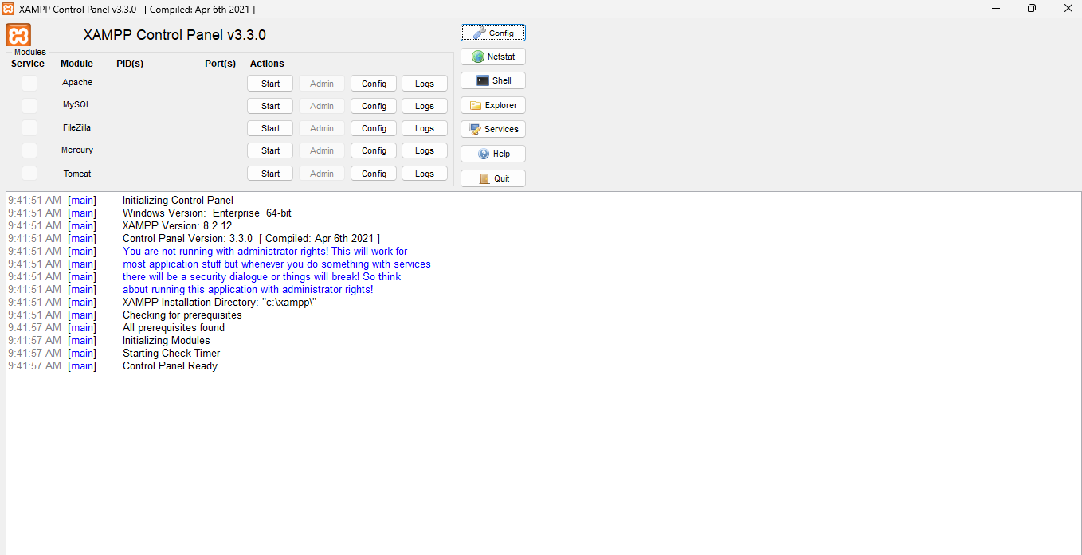
Fig 1.1 xampp installed
Apache and mySQL running:
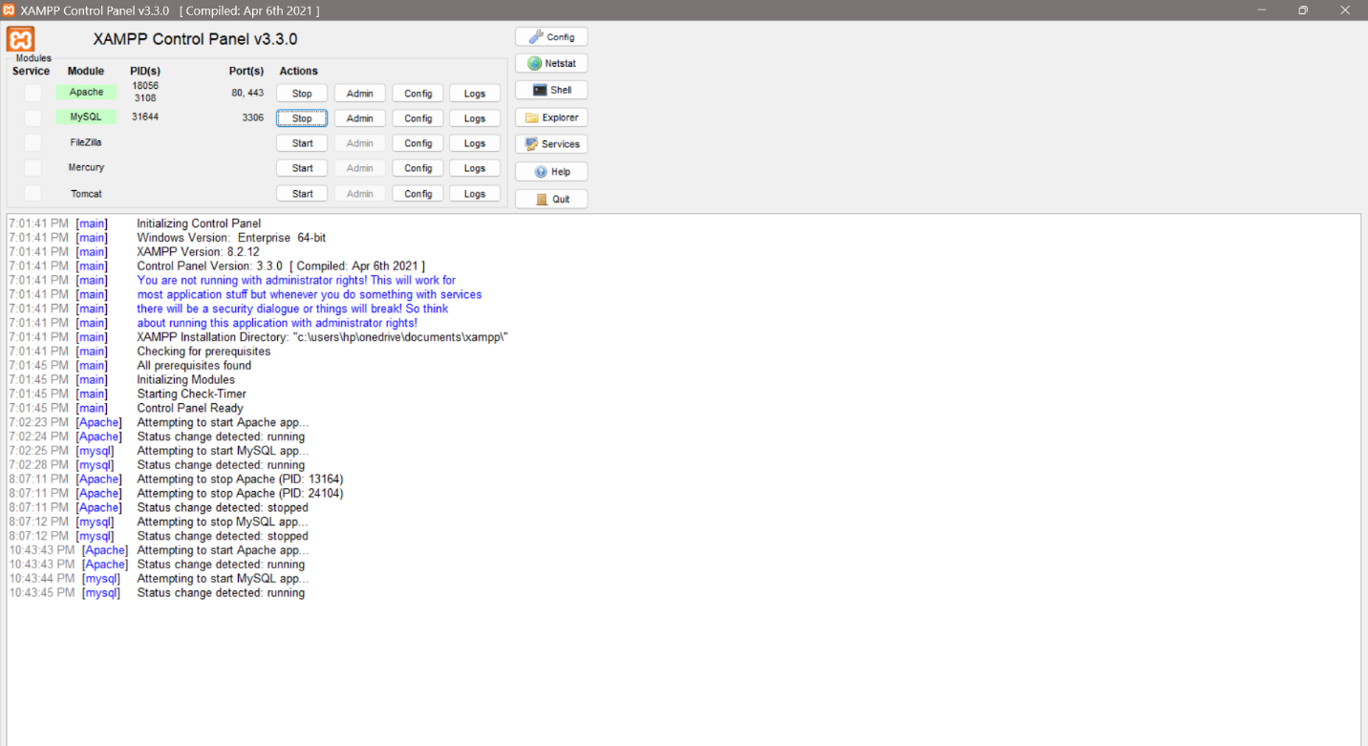
Fig 1.2 SQL run test

Hello World test:
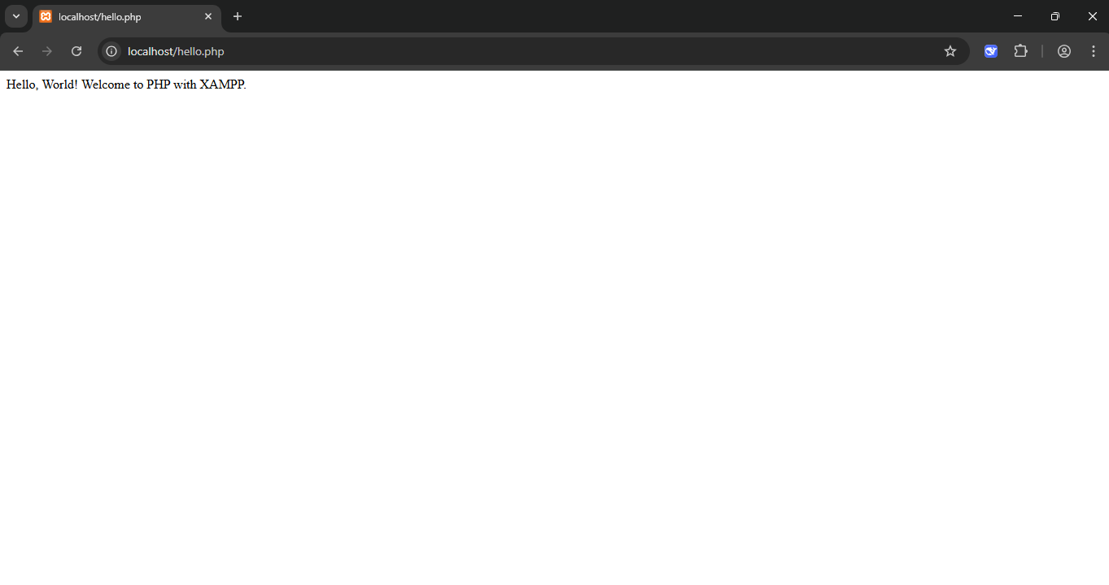
Fig 1.3 hello world test

Database Connection Test:
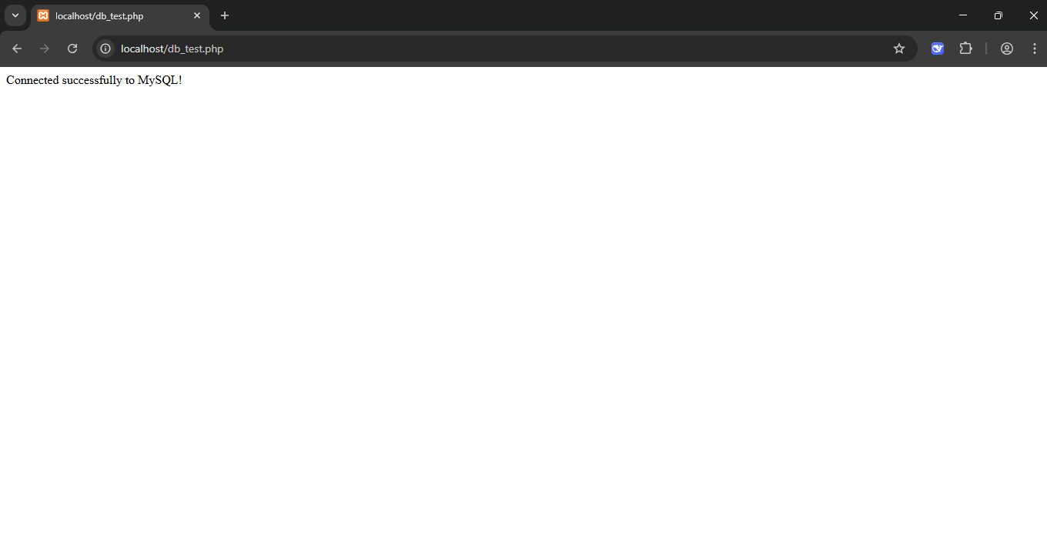
Fig 1.4 database connected

Reflection:
Through this project, I learned how to build a complete school management system using HTML, CSS, JavaScript, Node.js, Express, MySQL, and XAMPP. I gained experience in connecting a frontend to a backend and integrating a database using connection strings.

WEEK 2: Wireframes and UI Design

Wireframe GUI Design
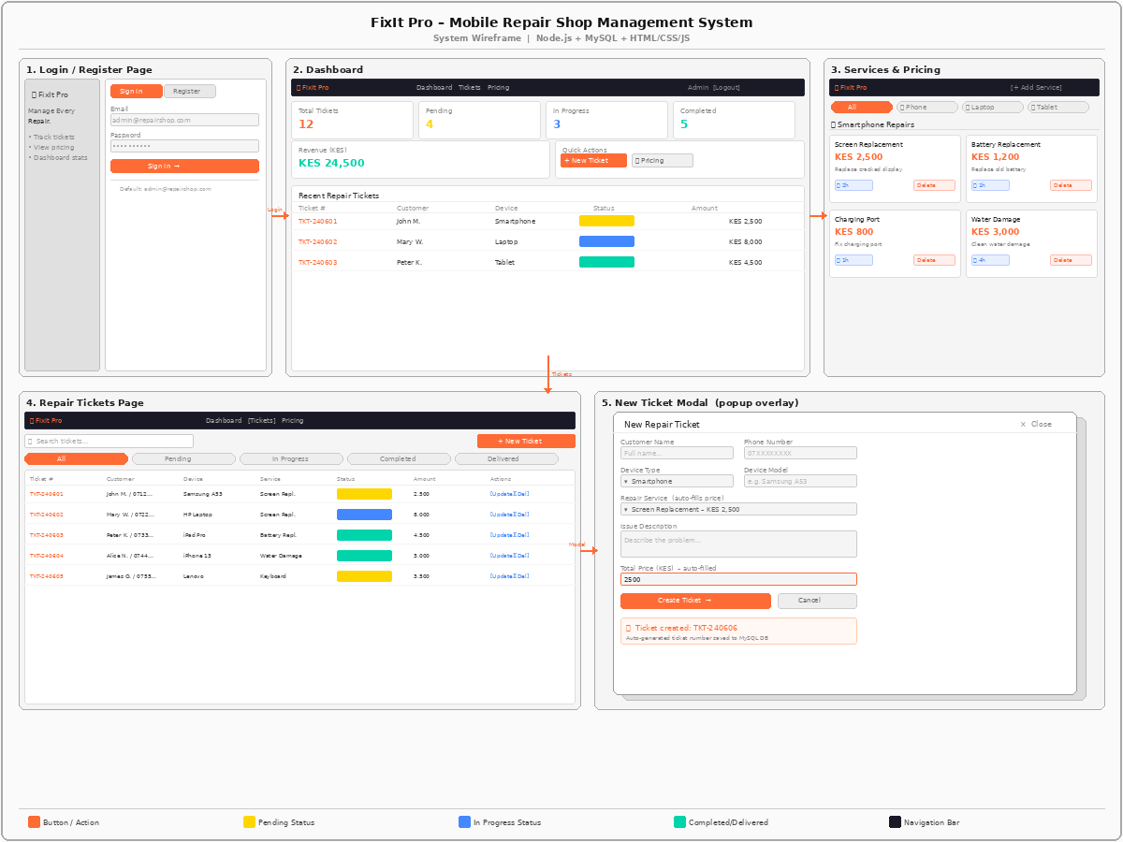

Technology | Used
HTML | Frontend structure
CSS | Styling
JavaScript | Frontend functionality
Node.js | Backend
Express.js | Server
MySQL | Database
XAMPP | Local database server

Implemented Javascript Basics
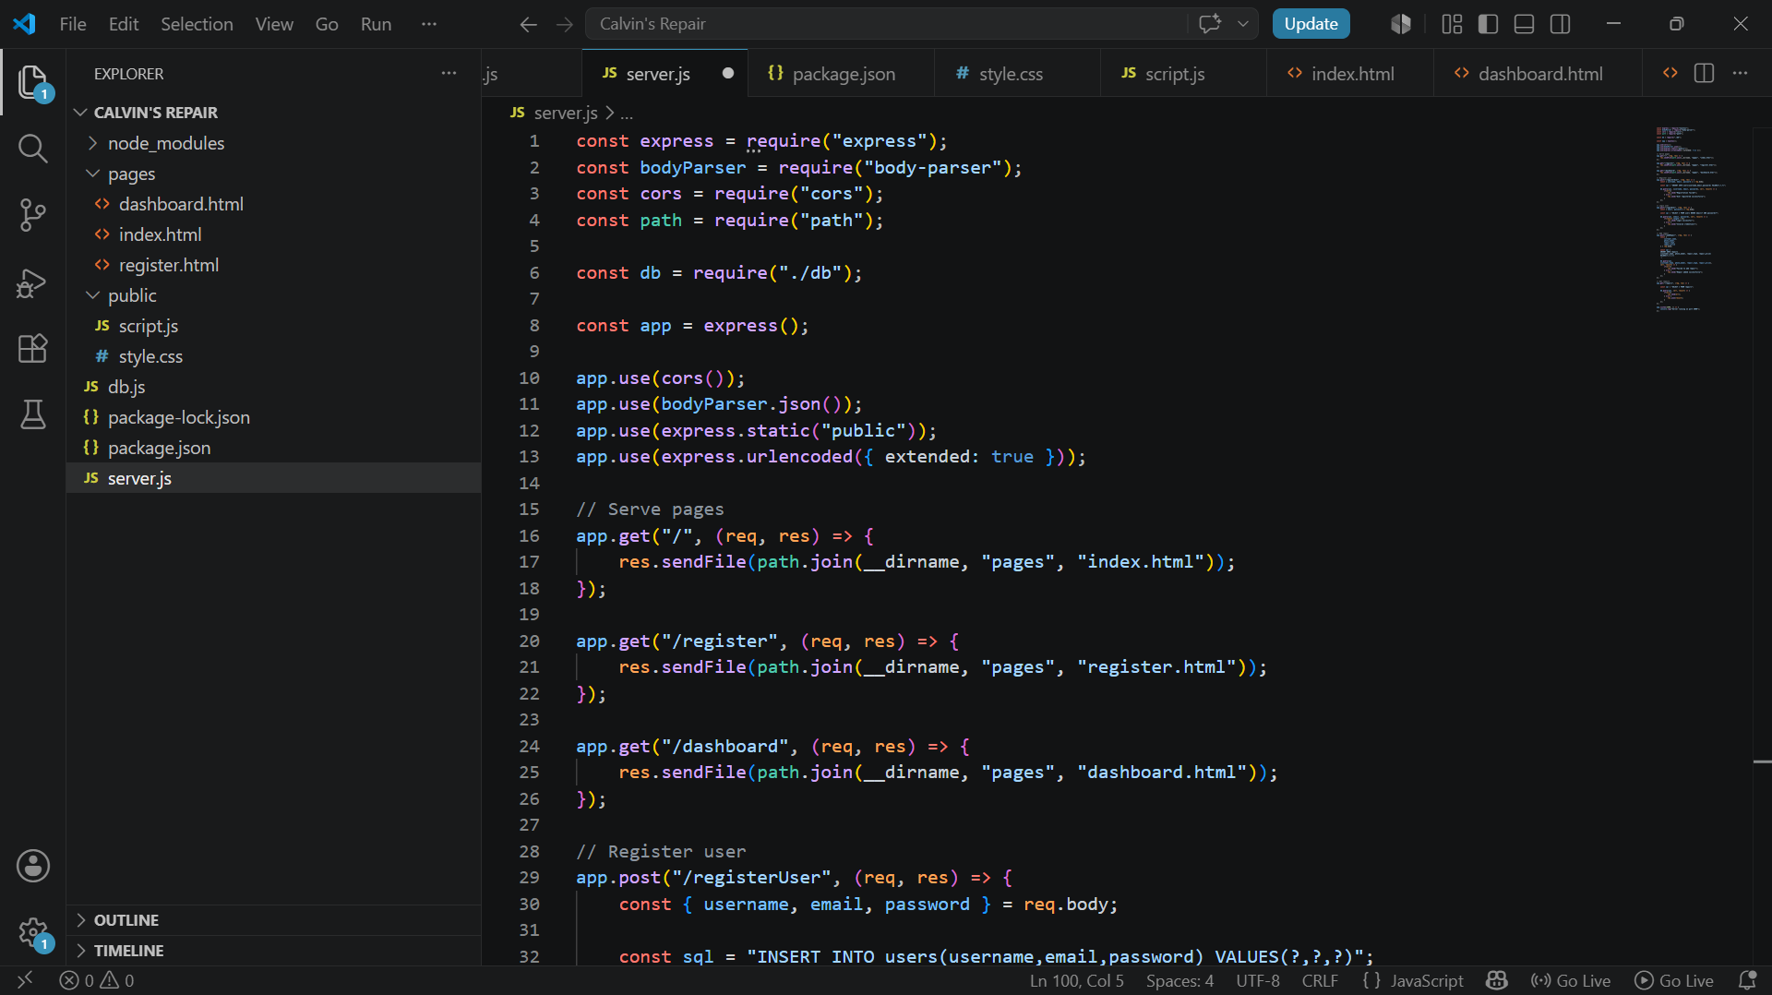
Fig 1.5 javascript codes

WEEK 3: JavaScript and DOM Manipulation
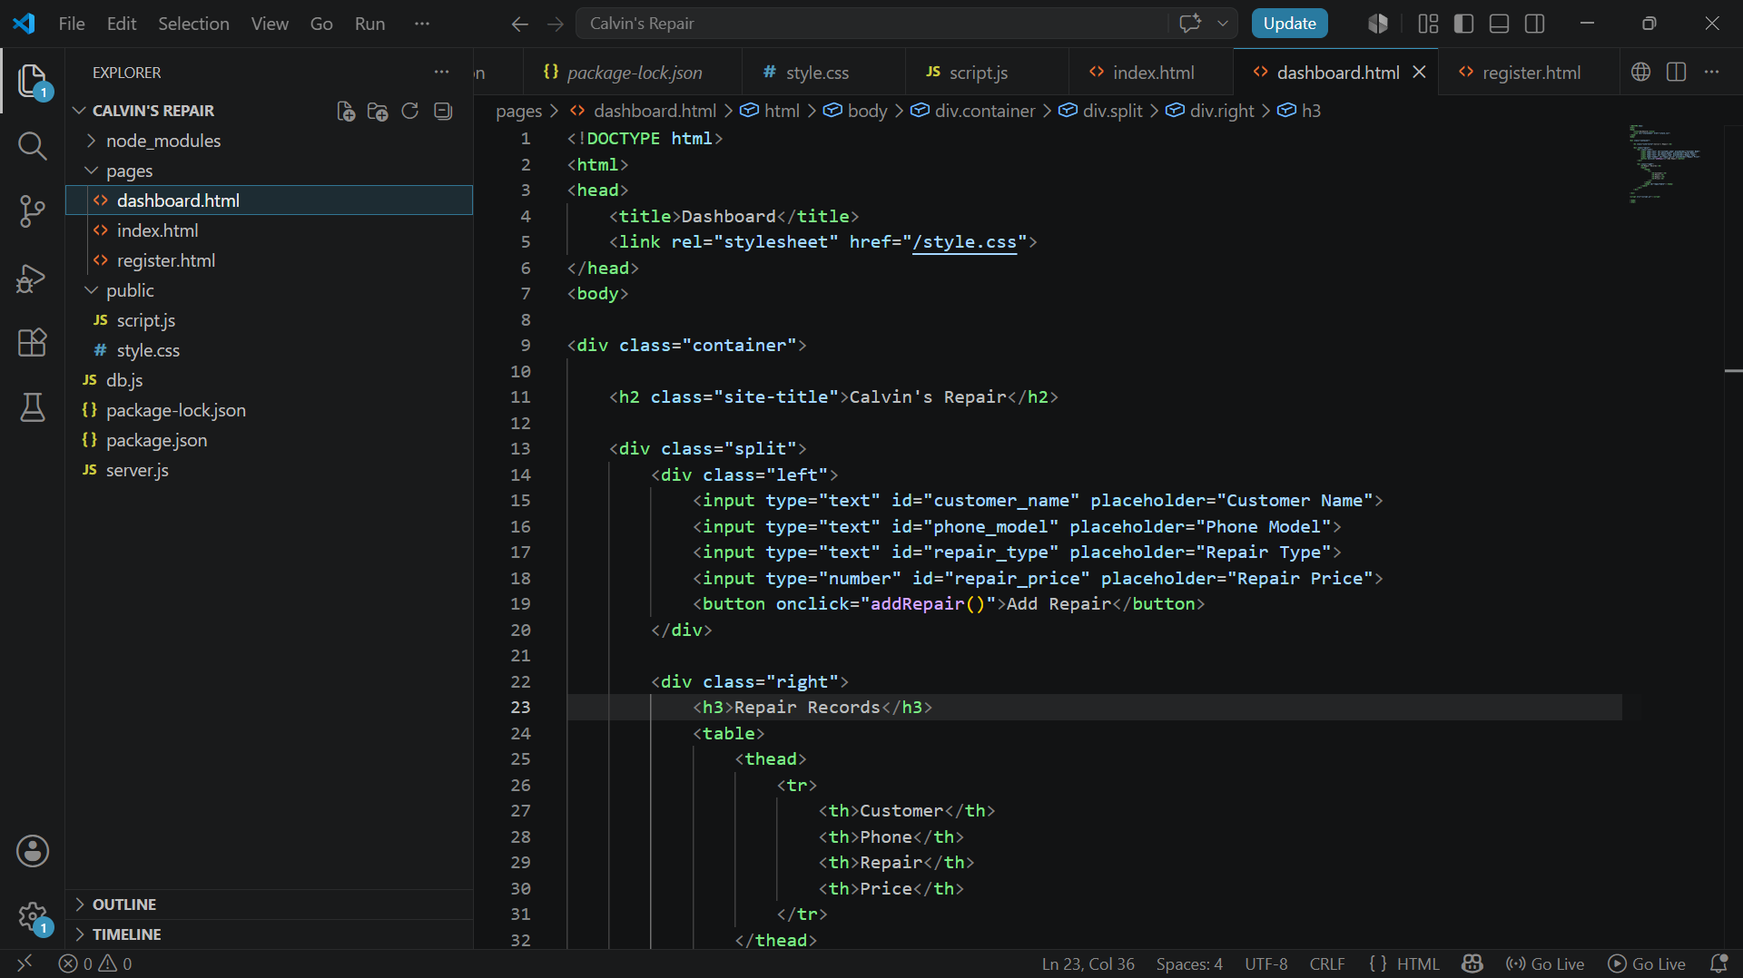
Fig 1.6 javascript programs

Created form Validation
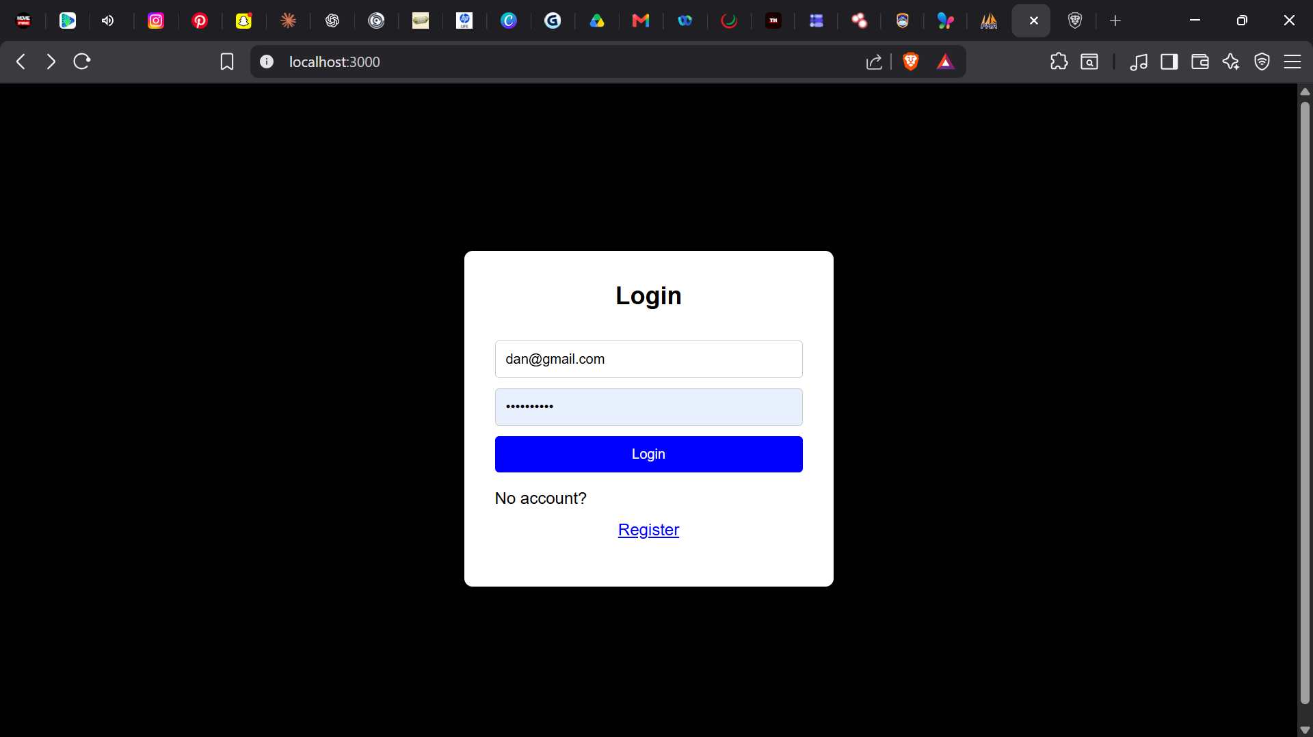
Fig 1.7 form validation

Database connection
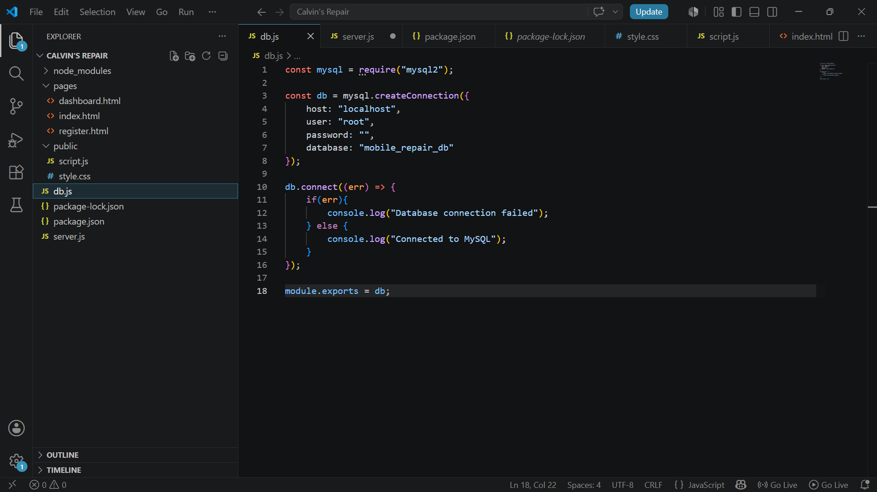
Fig 1.8 database connected

DOM Manipulation
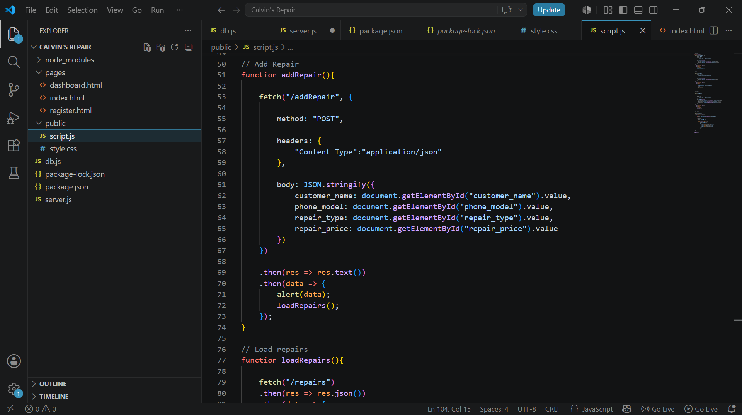
Reflection
During this project, I learnt how to connect a MySQL database using XAMPP and Node.js, use DOM manipulation to interact with web pages dynamically, and create login, register, and dashboard pages that allow users to manage mobile repair records efficiently.

WEEK 4: Server-Side Components and Backend

Folder Structure
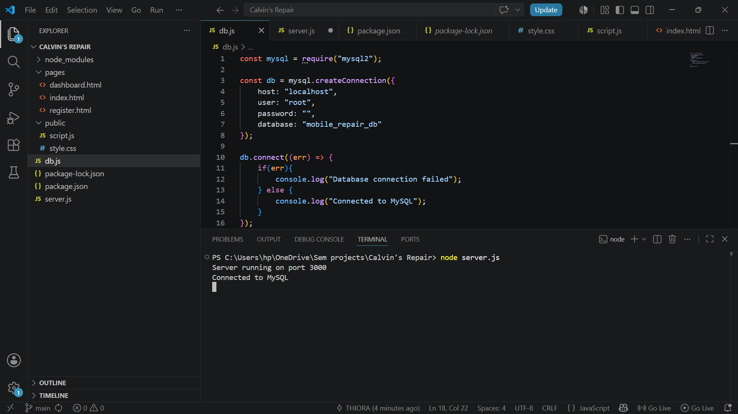

Fig 1.10 folder structure

Login form screenshots
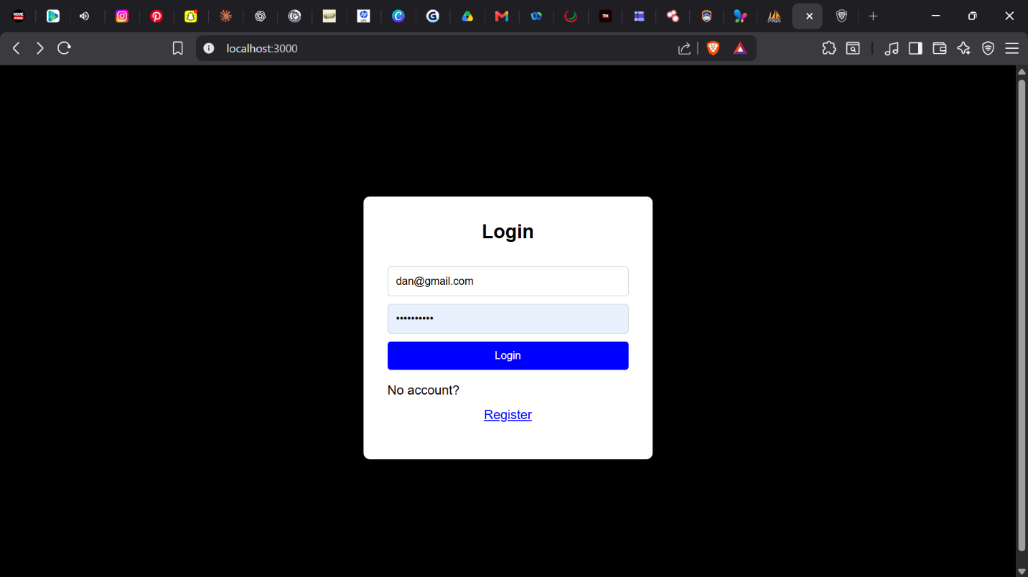
Fig 1.11 login page

Form validation screenshots
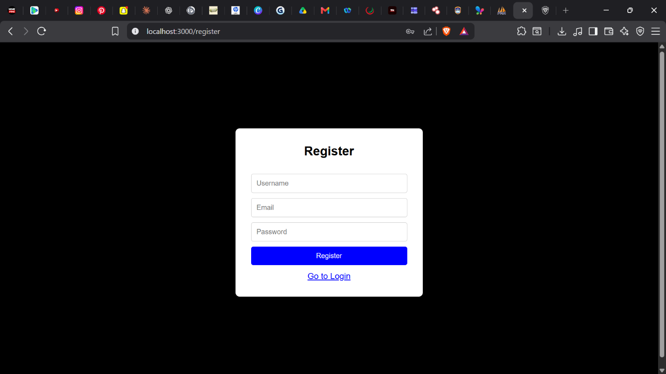
PHP processing screenshots
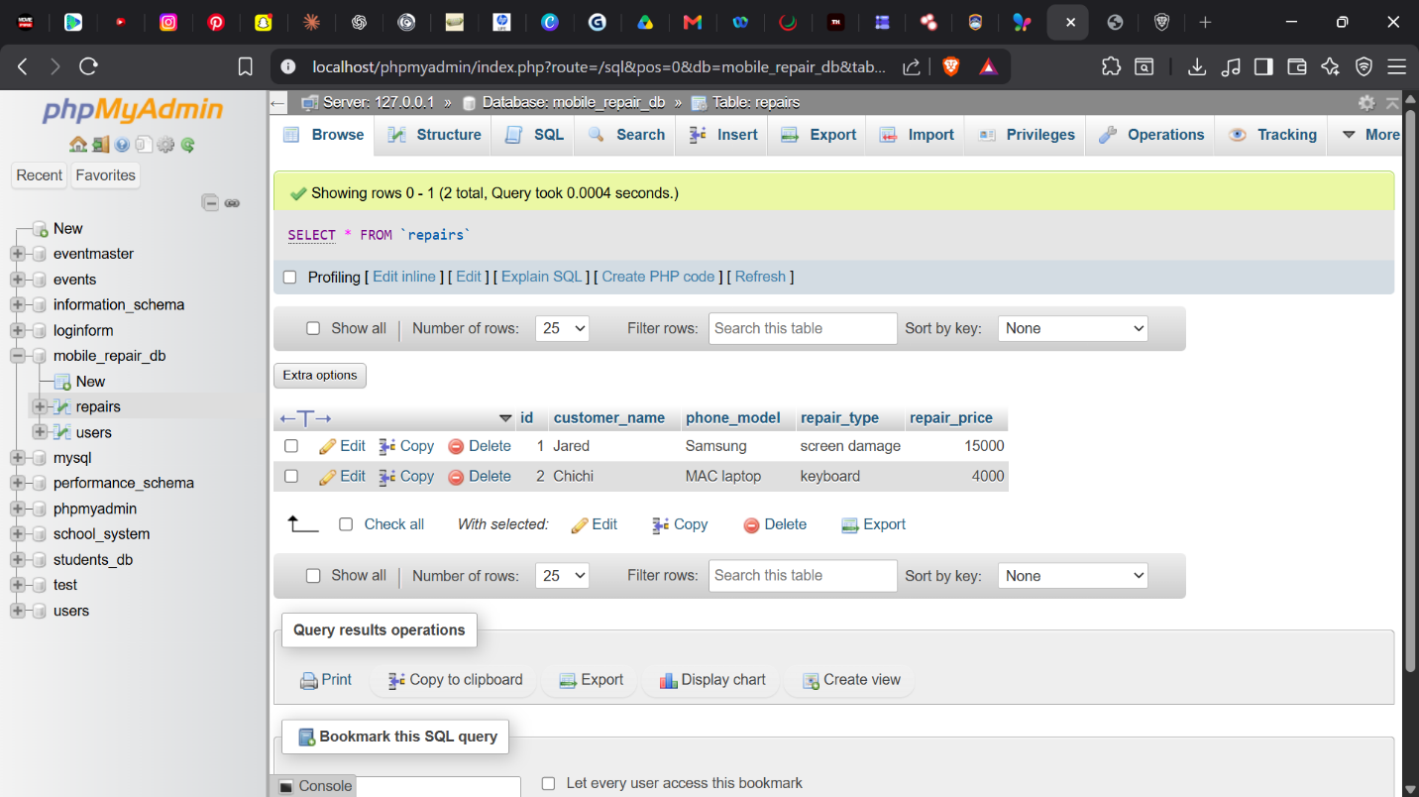
Fig 1.13 php connections

Reflection
During this project, I learnt how to implement form validation on login and registration pages, connect a MySQL database using backend connection code, and integrate GitHub for version control, project backup, and tracking development progress efficiently.

WEEK 5: Database and CRUD Operation
Github updates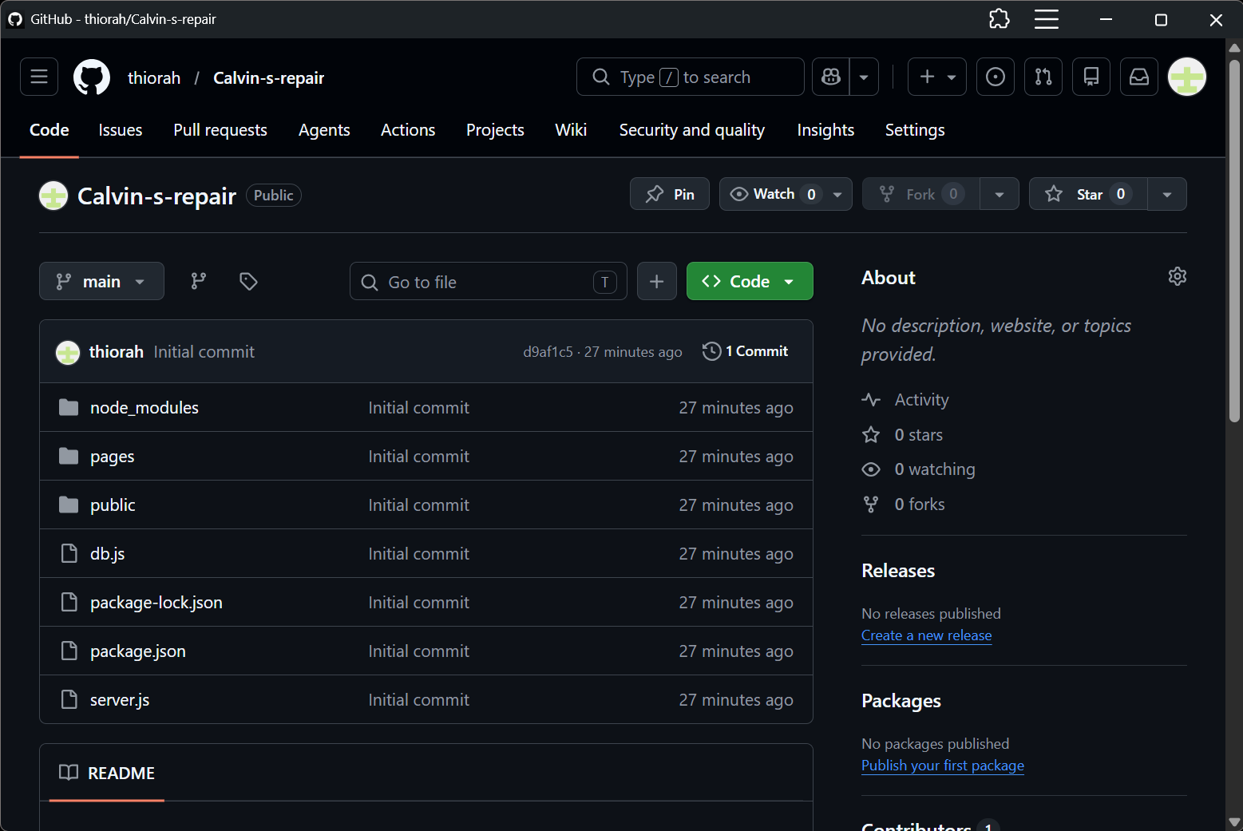

Table creation
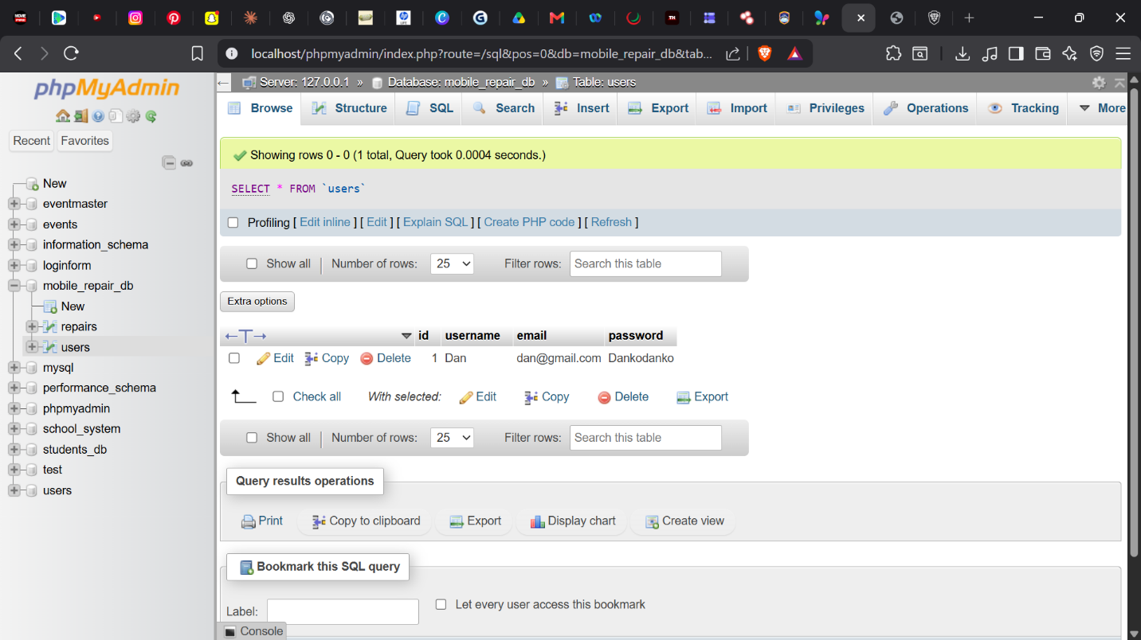

Webpage and database connections
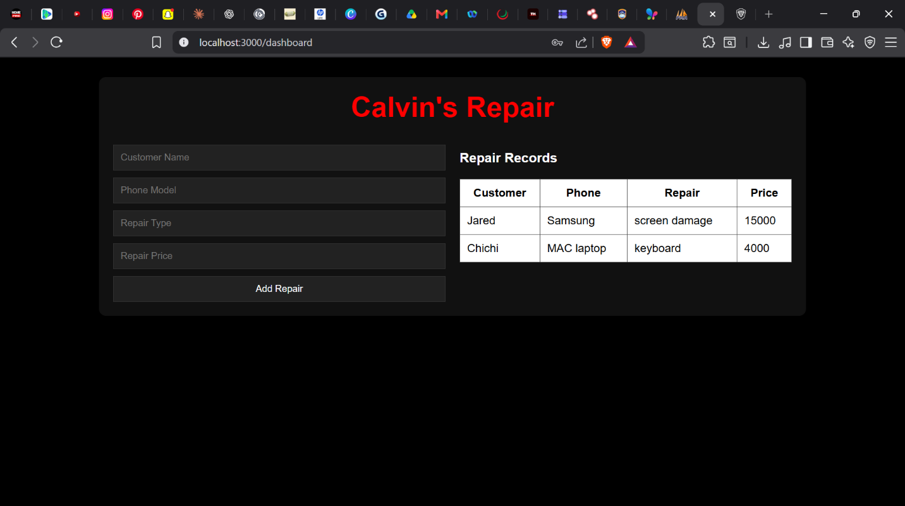

WEEK 6 – CRUD OPERATIONS

Records on database
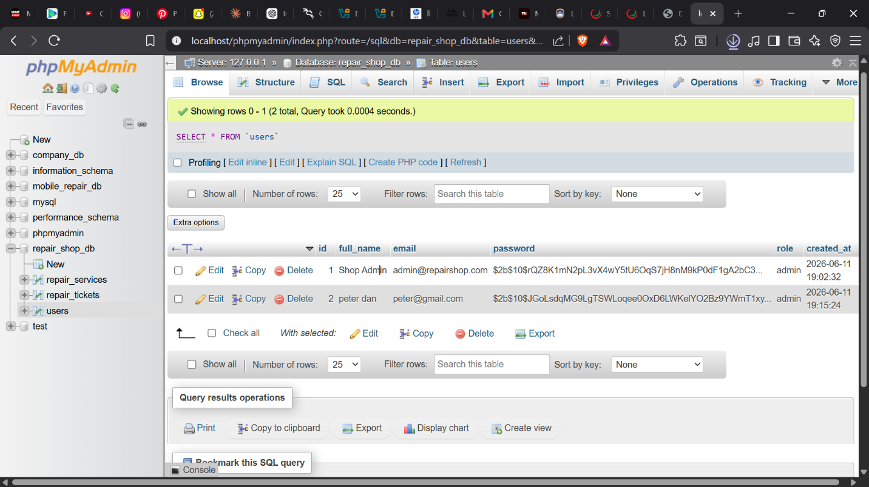

Update and Delete records
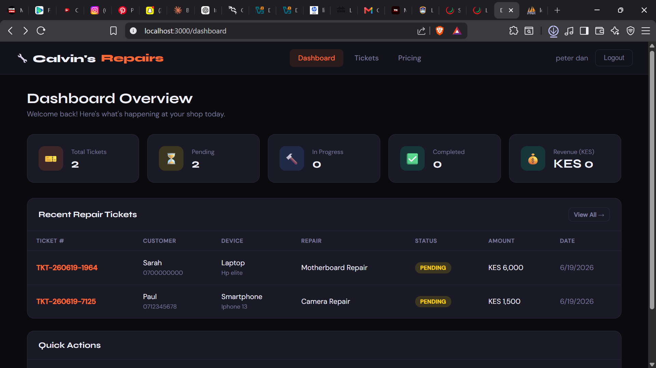

Database connection php
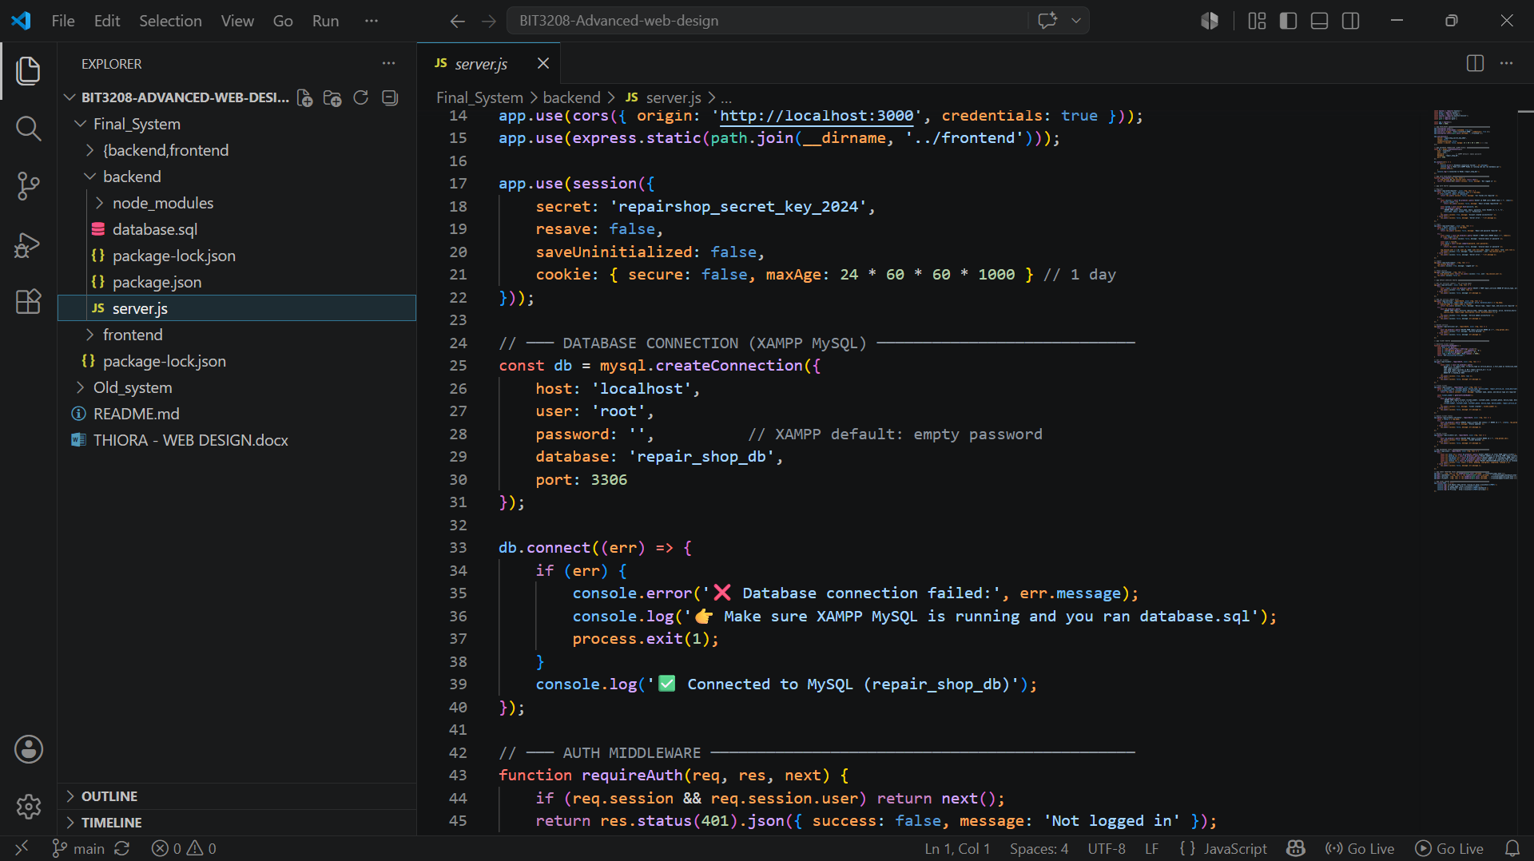

Reflection
This week I gained a solid understanding of structural Role-Based Access Control configurations. I was also able to create and connect databases and learnt CRUD operations.

WEEK 7 – USER AUTHENTICATION AND SESSION MANAGEMENT

Registration system


Login system


Secure Dashboard system


Reflection
I got to clearly understand different operations in database manipulation on different role assignment to different users and control access, i.e. admin, students and employees.

WEEK 8 - RESPONSIVE WEB DESIGN AND MOBILE FIRST DEVELOPMENT

Create a Responsive Personal Profile Page
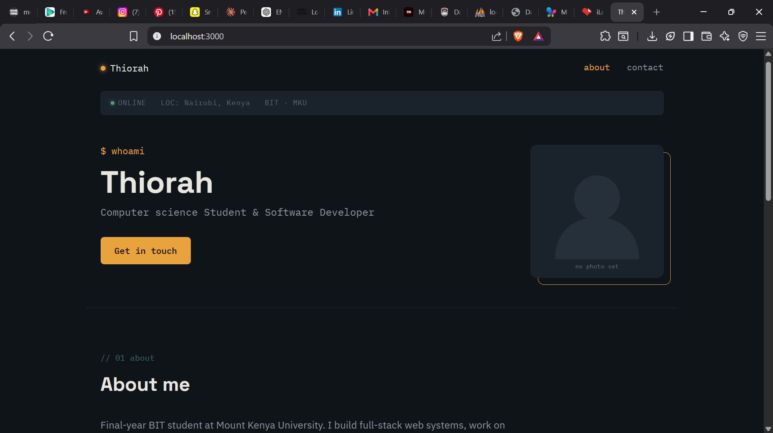

Build a Responsive Product Showcase
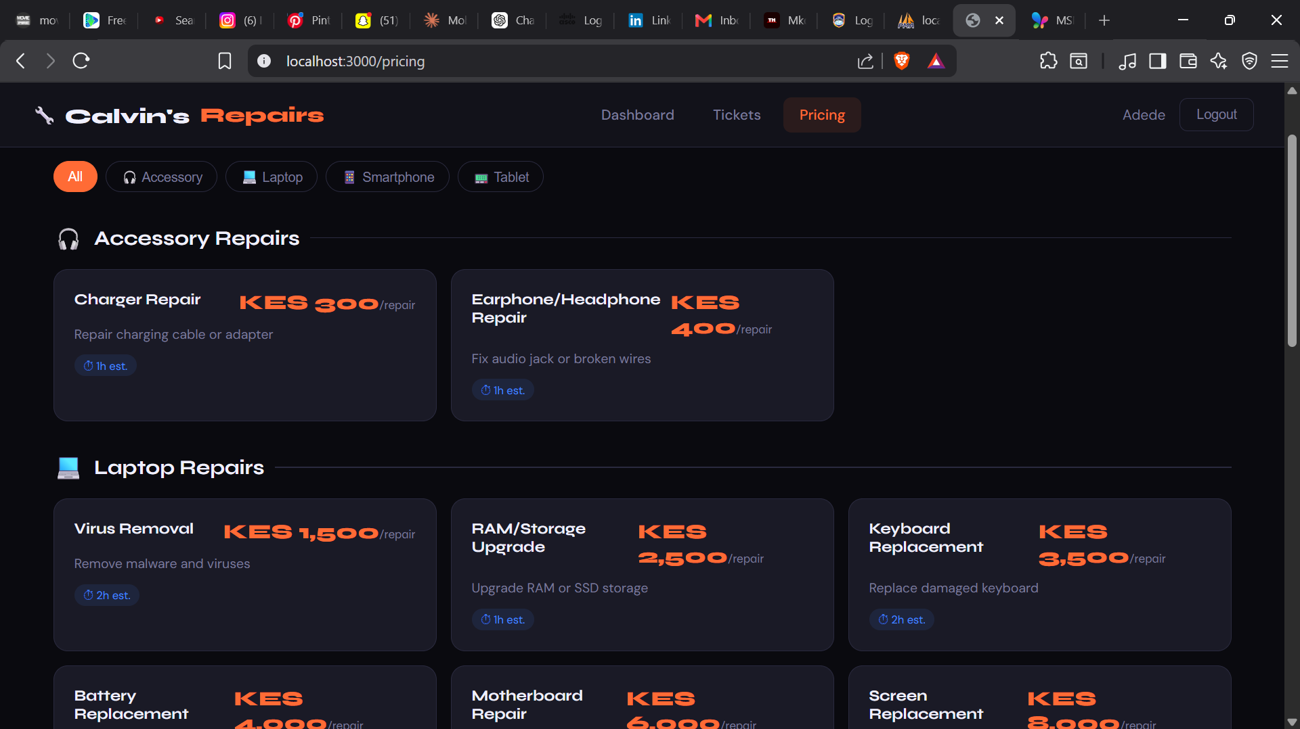

Reflection
This week I gained knowledge on real life and responsive web pages that can take in intake and give out the appropriate output. I got to learn how to make a responsive site using java script and CSS.

